Taylor Scholars Awards Program
E-mail: taylorawards@bellsouth.net

Respond by April 11 and reward your best students with FREE memberships to Louisiana attractions!

February 11, 2016

Dear Private School Principals, Guidance Counselors and Teachers,

It’s time to recognize your outstanding students! Audubon Nature Institute and the New Orleans Museum of Art (NOMA), in partnership with the Patrick F. Taylor Foundation, are rewarding young people with free annual memberships!

More than 196,000 Louisiana students earned free memberships in 2015, the 19th year of this statewide program. However, less than 33,000 were private school students! We know that many additional students were eligible to receive this tremendous reward, so we need your assistance to ensure that every qualified student is recognized in 2016!

Program qualifications are as follows:
- Those in grades 7 – 12 earning a 2.5-2.9 GPA during the 2015-16 school year are TAYLOR STUDENTS and will receive a one-year membership to Audubon Aquarium of the Americas, Audubon Butterfly Garden and Insectarium, and the New Orleans Museum of Art.
- Those in grades 7 – 12 earning a 3.0+ GPA during the 2015-16 school year are TAYLOR SCHOLARS and will receive the same as benefits as Taylor Students – plus a one-year membership to Audubon Zoo.

To participate, please identify qualified students in your school based on GPA as described above and submit the total number of Taylor Students and the total number of Taylor Scholars by April 11. The enclosed information sheet may help.

NOTE: Due to the recent passage of Acts #677 and #837 by the Louisiana Legislature, we can no longer request names or other data about your students. Instead, we ask that you submit only the number of qualifying students for each award. We will ship blank membership certificates for you to personalize and distribute to students.

We need all information no later than APRIL 11 to ensure students receive their awards by year end. We suggest schools use the latest grading period (typically 3rd quarter grades) to meet the APRIL 11 deadline. Submit your student information electronically via e-mail to taylorawards@bellsouth.net.

Contact us at (504) 889-8882 or learn more at AudubonInstitute.org/members/taylor or NOMA.org. We look forward to working with you to recognize your outstanding students!

Thank you in advance for your support,
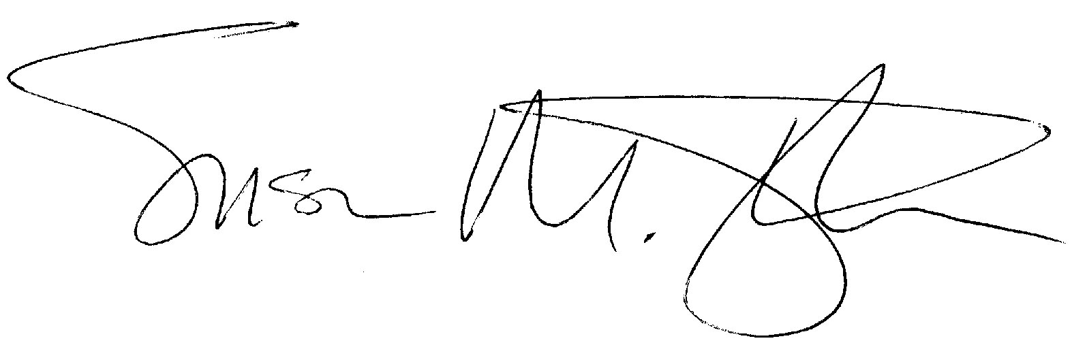
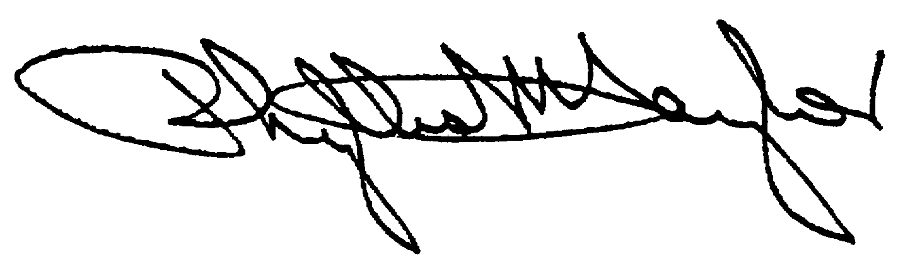
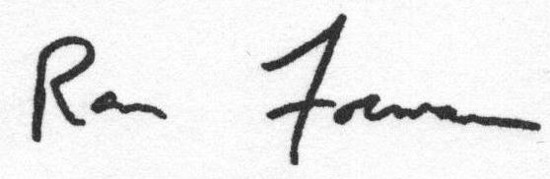

Phyllis M. Taylor Ron Forman Susan M. Taylor
Chairman and President President and C.E.O. The Montine McDaniel Freeman Director
Patrick F. Taylor Foundation Audubon Nature Institute New Orleans Museum of Art

