Taylor Scholars Awards Program
E-mail: taylorawards@bellsouth.net

February 11, 2016

Respond by April 11 and reward your best students with FREE memberships to Louisiana attractions!

Dear Diocese Leader,

It’s time to recognize your outstanding students! Audubon Nature Institute and the New Orleans Museum of Art (NOMA), in partnership with the Patrick F. Taylor Foundation, are rewarding young people with free annual memberships! Endorsed by the Board of Elementary & Secondary Education, the Taylor Scholars Awards Program rewards qualified 7-12 grade students with a certificate of achievement and free memberships to four of our state’s premier learning institutions.

Of the more than 196,000 students who earned free memberships in 2015, the 19th year of this statewide program, less than 33,000 were parochial school students. We know that many additional students were eligible to receive this tremendous reward, so we need your assistance to ensure that every qualified student is recognized in 2016.

Program qualifications are as follows:
- Those in grades 7 – 12 earning a 2.5-2.9 GPA during the 2015-16 school year are TAYLOR STUDENTS and will receive a one-year membership to Audubon Aquarium of the Americas, Audubon Butterfly Garden and Insectarium, and the New Orleans Museum of Art.
- Those in grades 7 – 12 earning a 3.0+ GPA during the 2015-16 school year are TAYLOR SCHOLARS and will receive the same as benefits as Taylor Students – plus a one-year membership to Audubon Zoo.

Letters are mailed to each parochial school principal and guidance counselor in your area explaining program details and deadlines. Please assist by encouraging the principals of your schools to participate in this worthwhile program – to reward students with free admission to top attractions.

NOTE: Due to the recent passage of Acts #677 and #837 by the Louisiana Legislature, we can no longer request names or other data about your students. Instead, this year, we ask that schools submit only the number of qualifying students for each award level. We will ship blank membership certificates for schools to personalize and distribute to students.

We need all information by APRIL 11, 2016 to ensure students receive their awards by end of the academic year. We suggest schools use the latest grading period (typically 3rd quarter grades) to meet the April 11 deadline.

We look forward to working with you to recognize outstanding students! Learn more by visiting AudubonInstitute.org/members/taylor or NOMA.org. Or, contact us at taylorawards@bellsouth.net or (504) 889-8882.

Thanks in advance for your support!
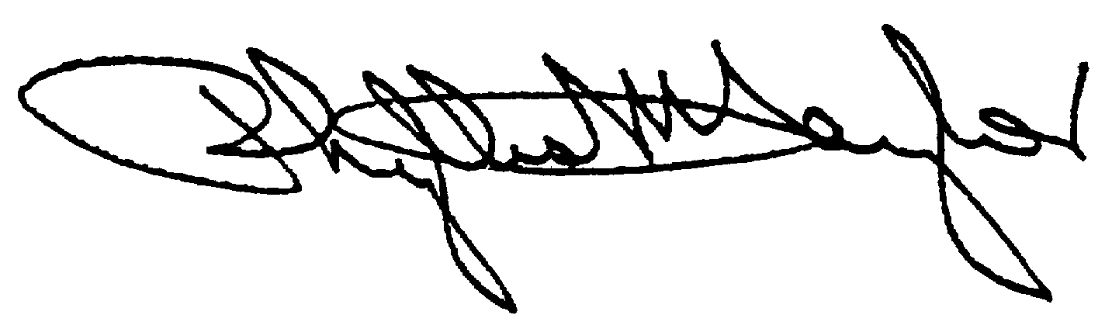
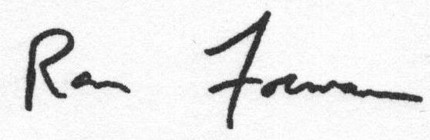
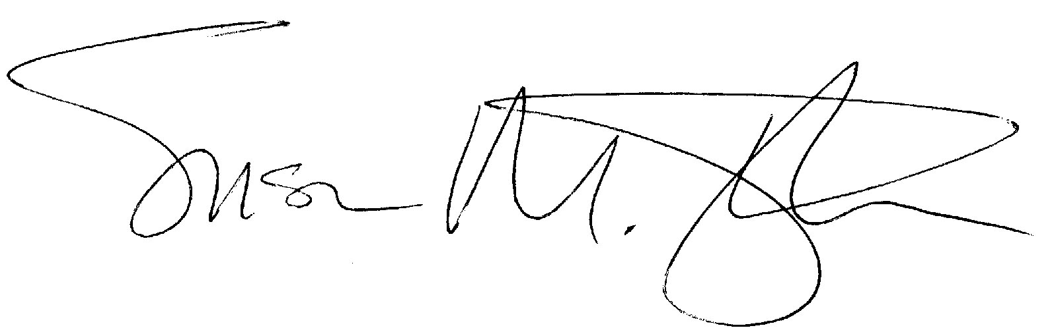

Phyllis M. Taylor L. Ronald Forman Susan M. Taylor
Chairman and President President and CEO The Montine McDaniel Freeman Director
Patrick F. Taylor Foundation Audubon Nature Institute New Orleans Museum of Art

